11g installation and how to connect daily.

Relational Operators : <, >, <=, >=

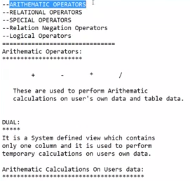

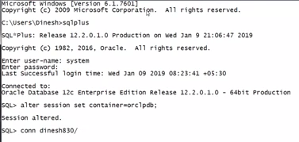

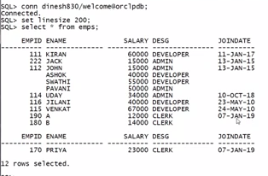

If we want to get specific data , we need to use condition according to the requirement.

We can write a condition using relational operators.

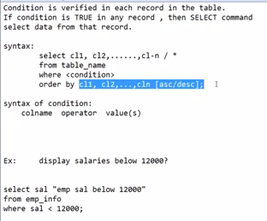

First and highest priority is for where clause

And least priority is for order by clause.

Character value and date value should be enclosed under single quotations.

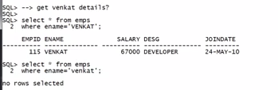

Data in table is case sensitive.

